**Postgres Queries Screen Shot:**

**1.Total sales $ -   
Query:**Select Sum("InvoiceLine"."Quantity" * "InvoiceLine"."UnitPrice") AS TotalSales FROM "InvoiceLine"; 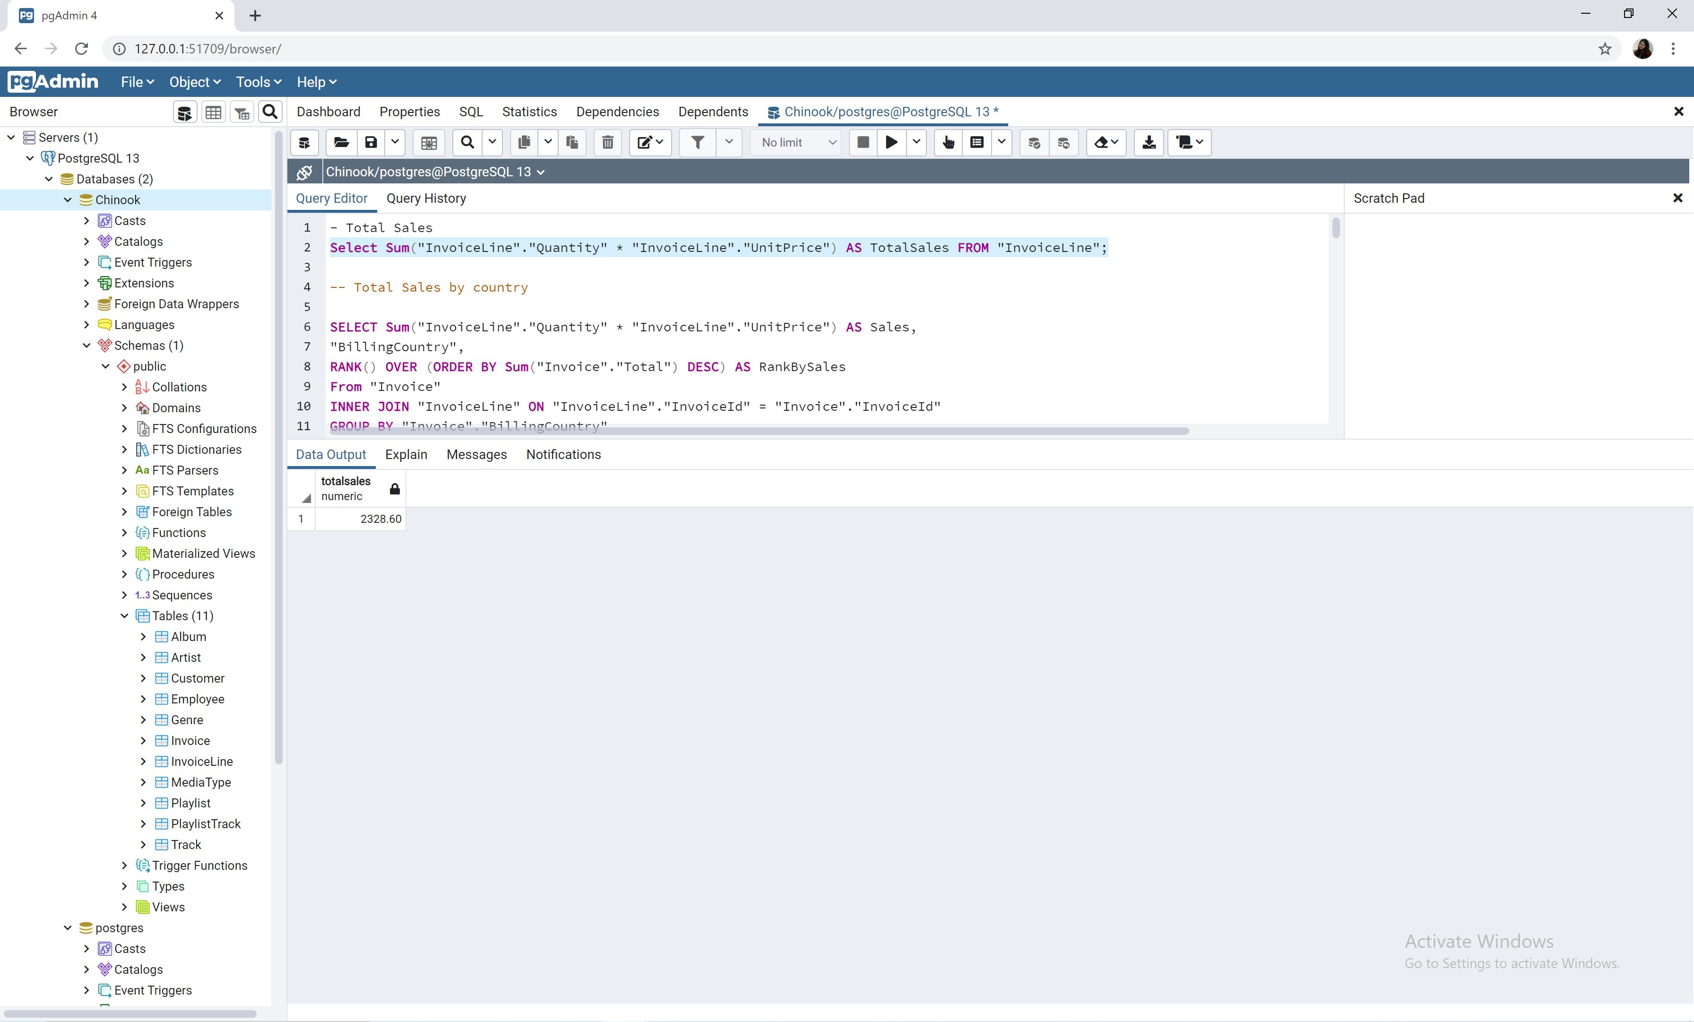

**2.Total sales $ by country –ranked (or at least sorted largest to smallest) -**SELECT Sum("InvoiceLine"."Quantity" * "InvoiceLine"."UnitPrice") AS Sales,

"BillingCountry",

RANK() OVER (ORDER BY Sum("Invoice"."Total") DESC) AS RankBySales

From "Invoice"

INNER JOIN "InvoiceLine" ON "InvoiceLine"."InvoiceId" = "Invoice"."InvoiceId"

GROUP BY "Invoice"."BillingCountry"

ORDER BY 1 DESC 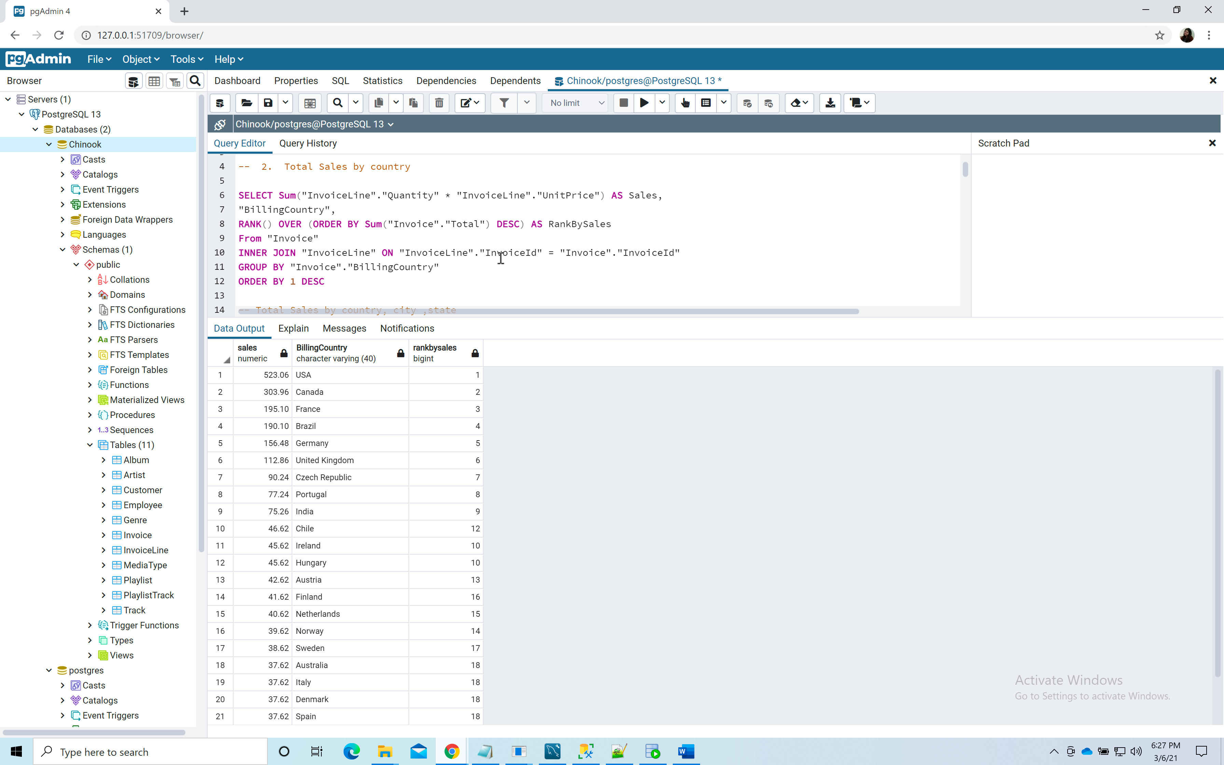

**3.Total sales $ by country, state & city -   
Query:**

SELECT Sum("InvoiceLine"."Quantity" * "InvoiceLine"."UnitPrice") AS "Sales", "BillingCountry" , "BillingCity", "BillingState"

From "Invoice"

INNER JOIN "InvoiceLine" ON "InvoiceLine"."InvoiceId" = "Invoice"."InvoiceId"

WHERE "BillingState" IS NOT NULL

GROUP BY "Invoice"."BillingCountry", "Invoice"."BillingCity", "Invoice"."BillingState"

ORDER BY 1 DESC

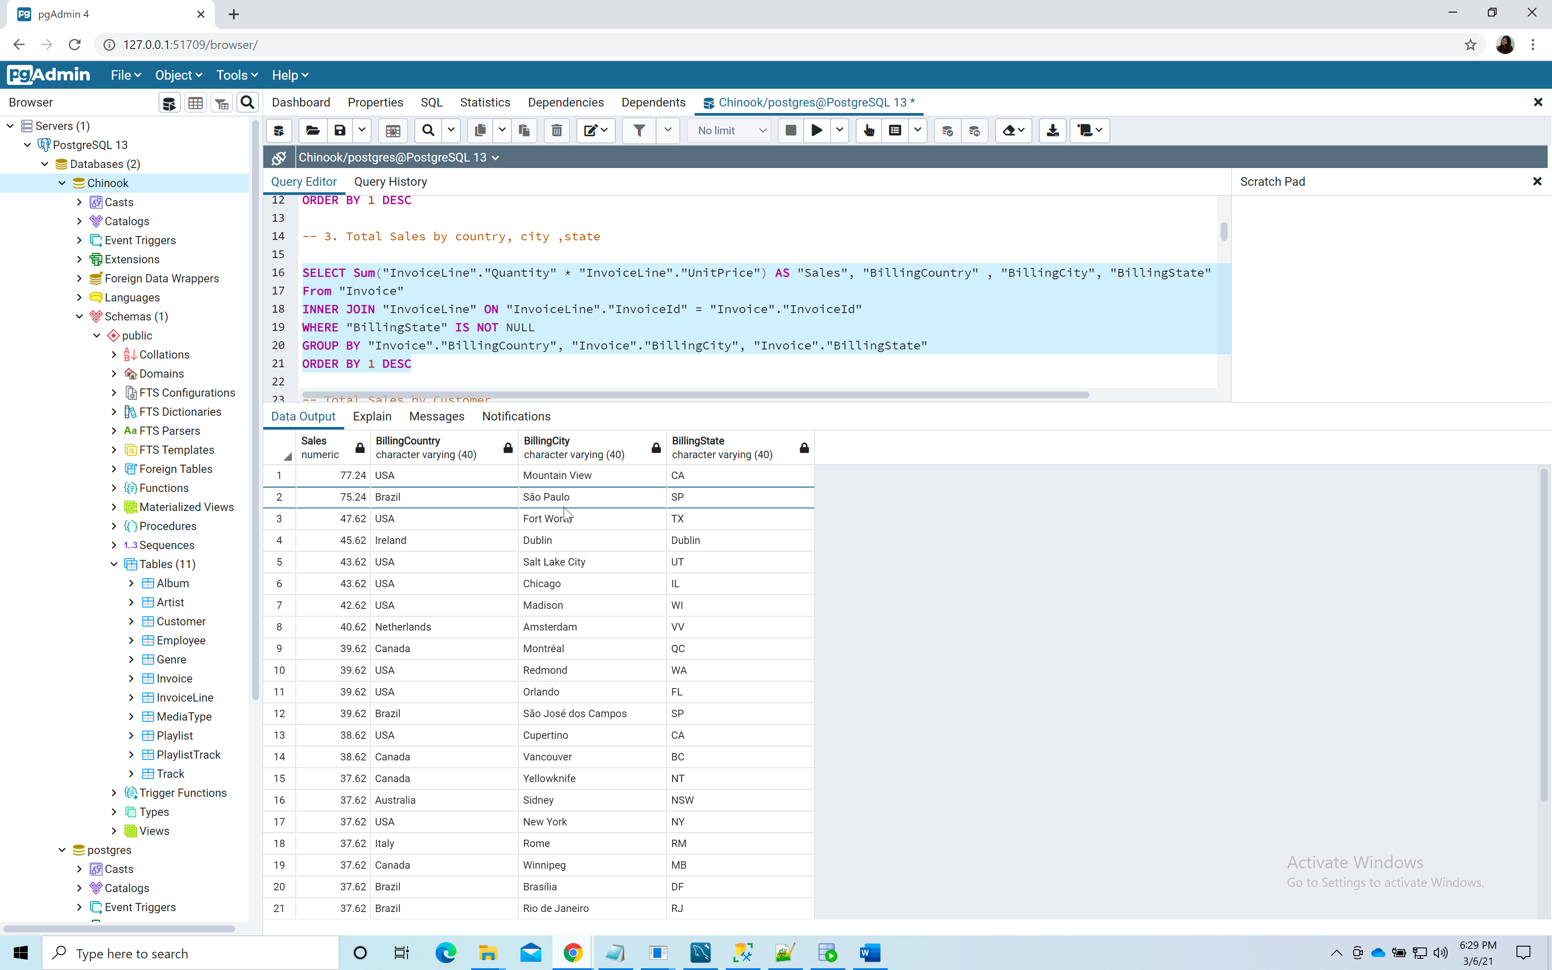

**4.Total sales $ by customer (a person with last name & first name) –ranked (or at least sorted largest to smallest)  
Query:**

SELECT CONCAT("LastName",' , ',"FirstName")AS "CustomerName",Sum("InvoiceLine"."Quantity" * "InvoiceLine"."UnitPrice") AS "Sales",

RANK() OVER (ORDER BY Sum("InvoiceLine"."Quantity" * "InvoiceLine"."UnitPrice") DESC) AS RankBySales

FROM "Customer"

INNER JOIN "Invoice" on "Invoice"."CustomerId" = "Customer"."CustomerId"

INNER JOIN "InvoiceLine" ON "InvoiceLine"."InvoiceId" = "Invoice"."InvoiceId"

GROUP BY "Customer"."LastName", "Customer"."FirstName"

ORDER BY 2 DESC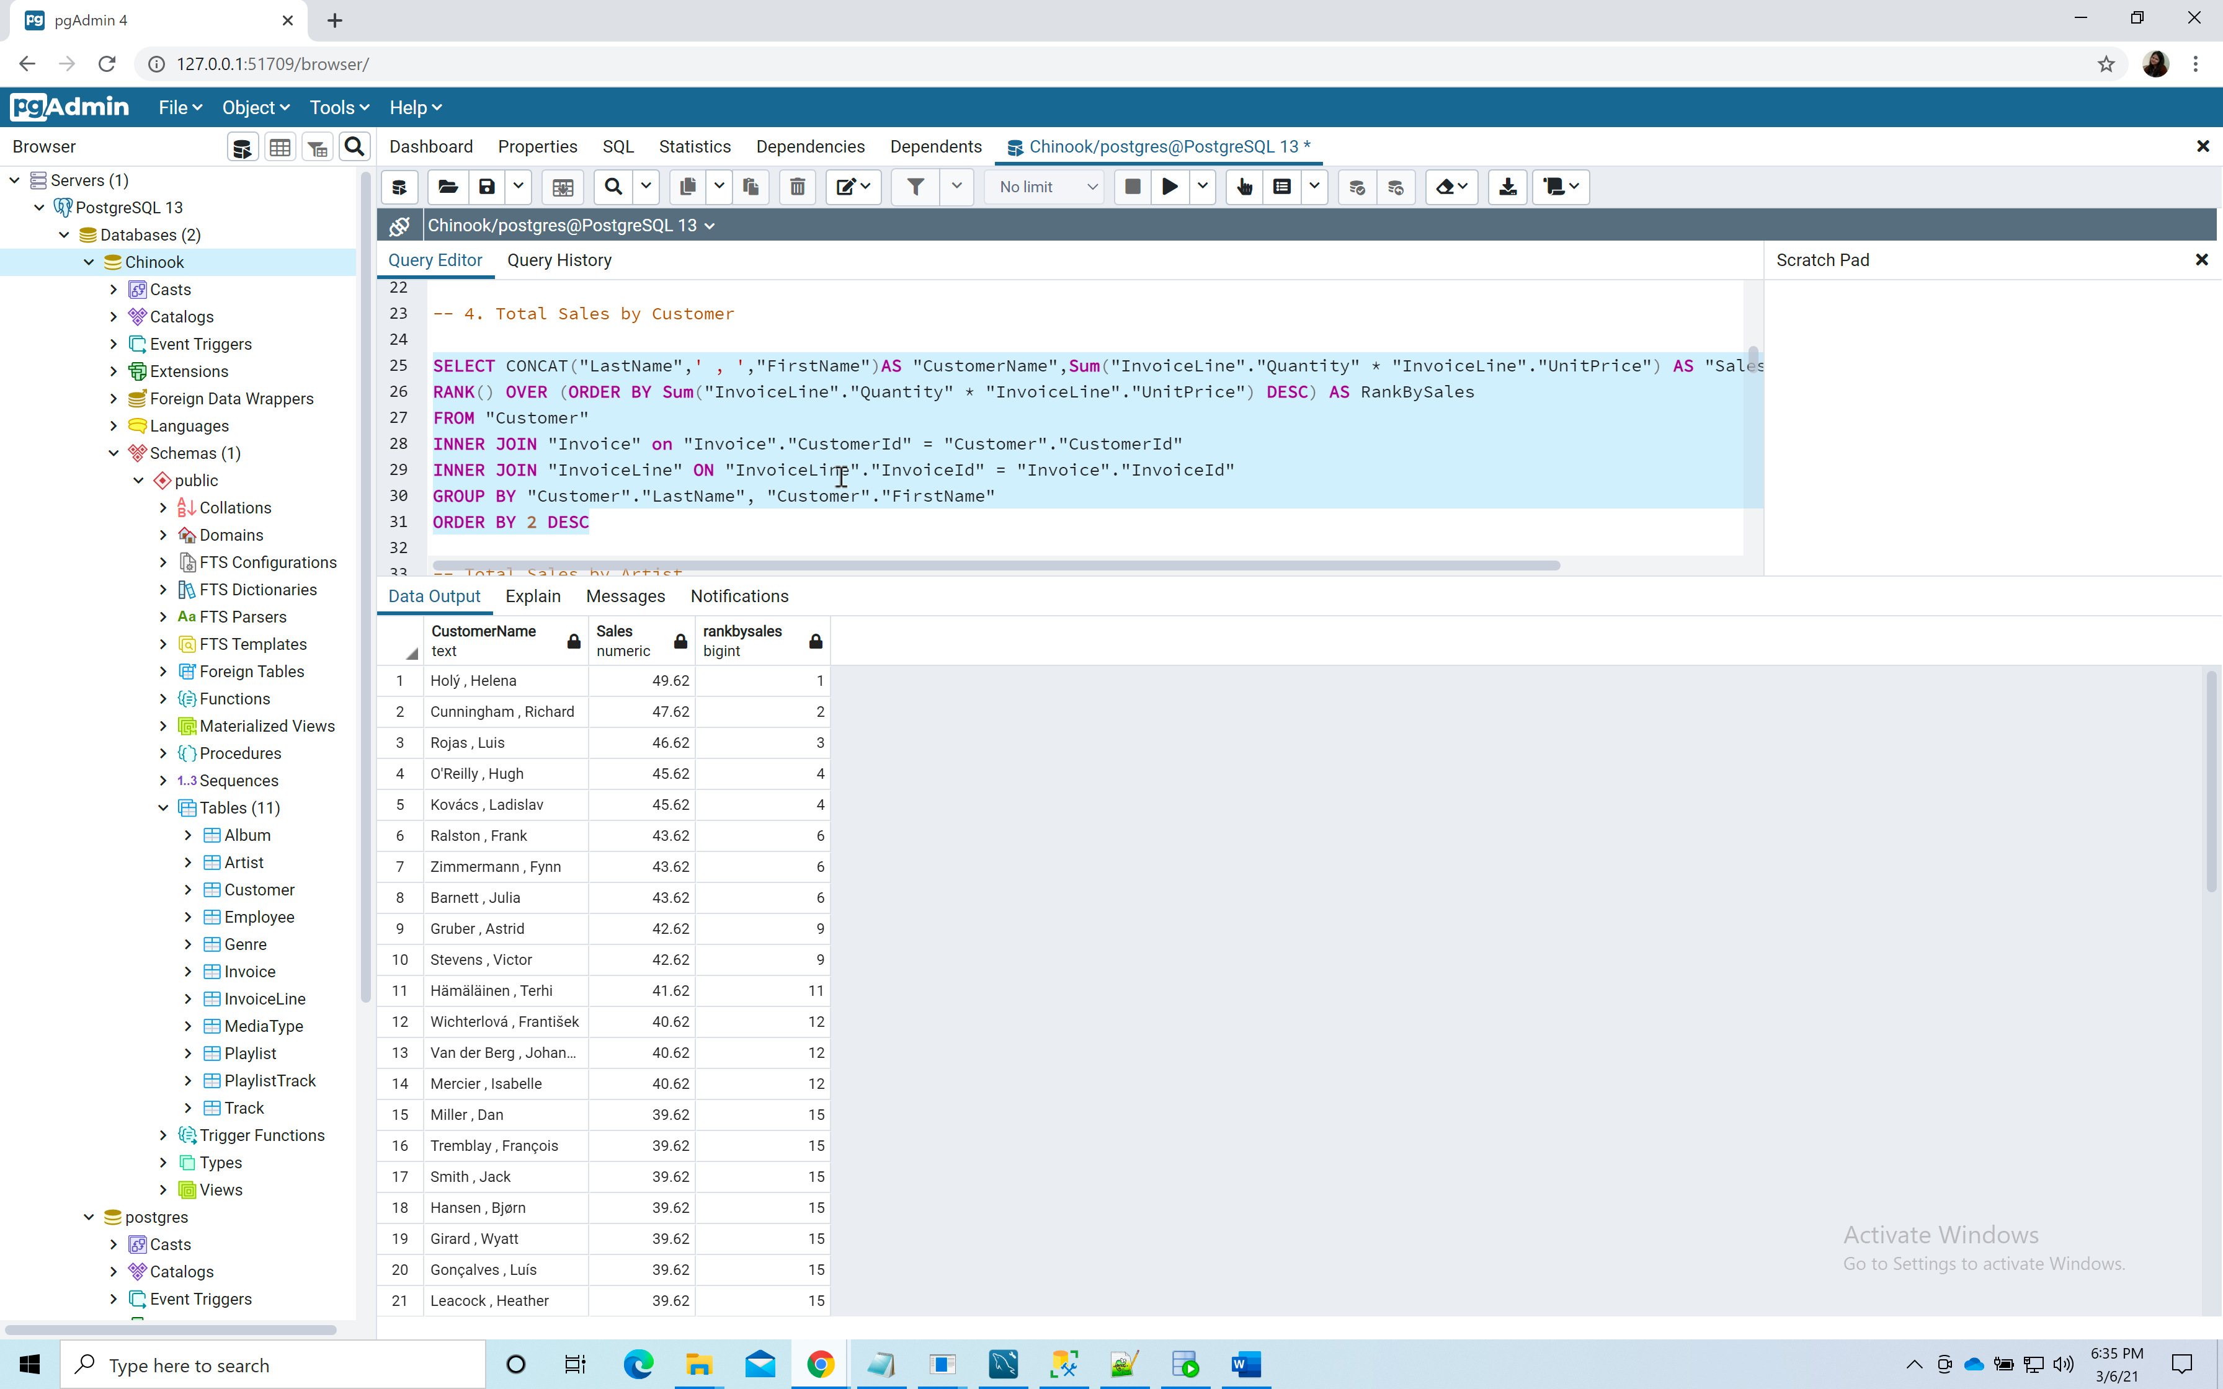

**5.Total sales $ by artist –ranked (or at least sorted largest to smallest)  
Query:**

SELECT "Artist"."Name" AS "Artist_Name", Sum("InvoiceLine"."Quantity" * "InvoiceLine"."UnitPrice") AS "Sales",

RANK() OVER (ORDER BY Sum("InvoiceLine"."Quantity" * "InvoiceLine"."UnitPrice") DESC) AS RankBySales

From "Artist"

INNER JOIN "Album" ON "Album"."ArtistId" = "Artist"."ArtistId"

INNER JOIN "Track" ON "Track"."AlbumId" = "Album"."AlbumId"

INNER JOIN "InvoiceLine" ON "InvoiceLine"."TrackId" = "Track"."TrackId"

INNER JOIN "Invoice" ON "Invoice"."InvoiceId" = "InvoiceLine"."InvoiceId"

Group by "Artist"."Name"

ORDER BY 2 DESC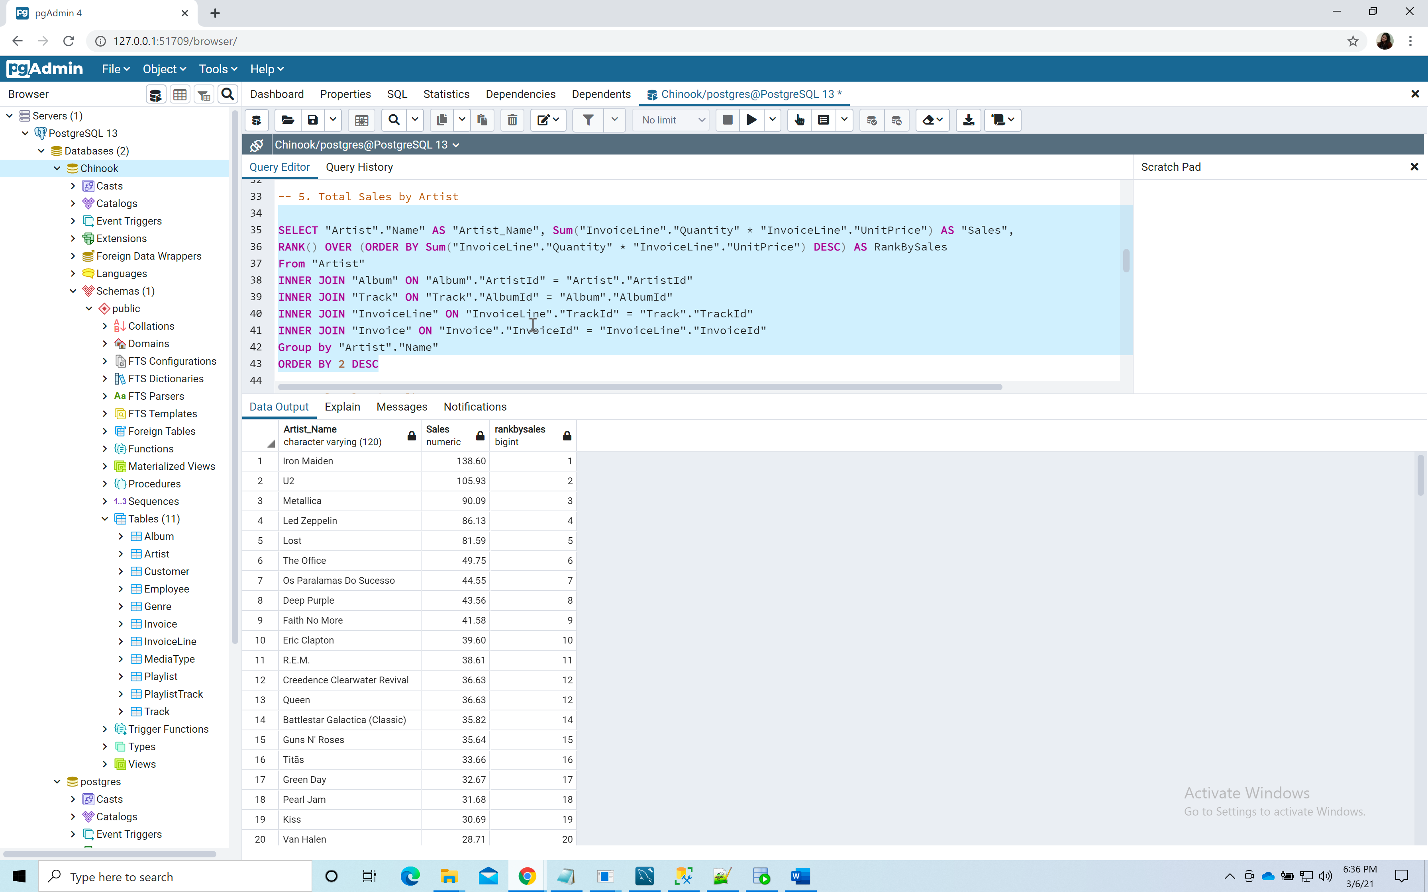

**6.Total sales $ by albums  
Query:**

SELECT "Album"."Title" AS "Album_Name", Sum("InvoiceLine"."Quantity" * "InvoiceLine"."UnitPrice") AS "Sales"

From "Album"

INNER JOIN "Track" ON "Track"."AlbumId" = "Album"."AlbumId"

INNER JOIN "InvoiceLine" ON "InvoiceLine"."TrackId" = "Track"."TrackId"

INNER JOIN "Invoice" ON "Invoice"."InvoiceId" = "InvoiceLine"."InvoiceId"

Group by "Album"."Title"

ORDER BY 2 DESC  
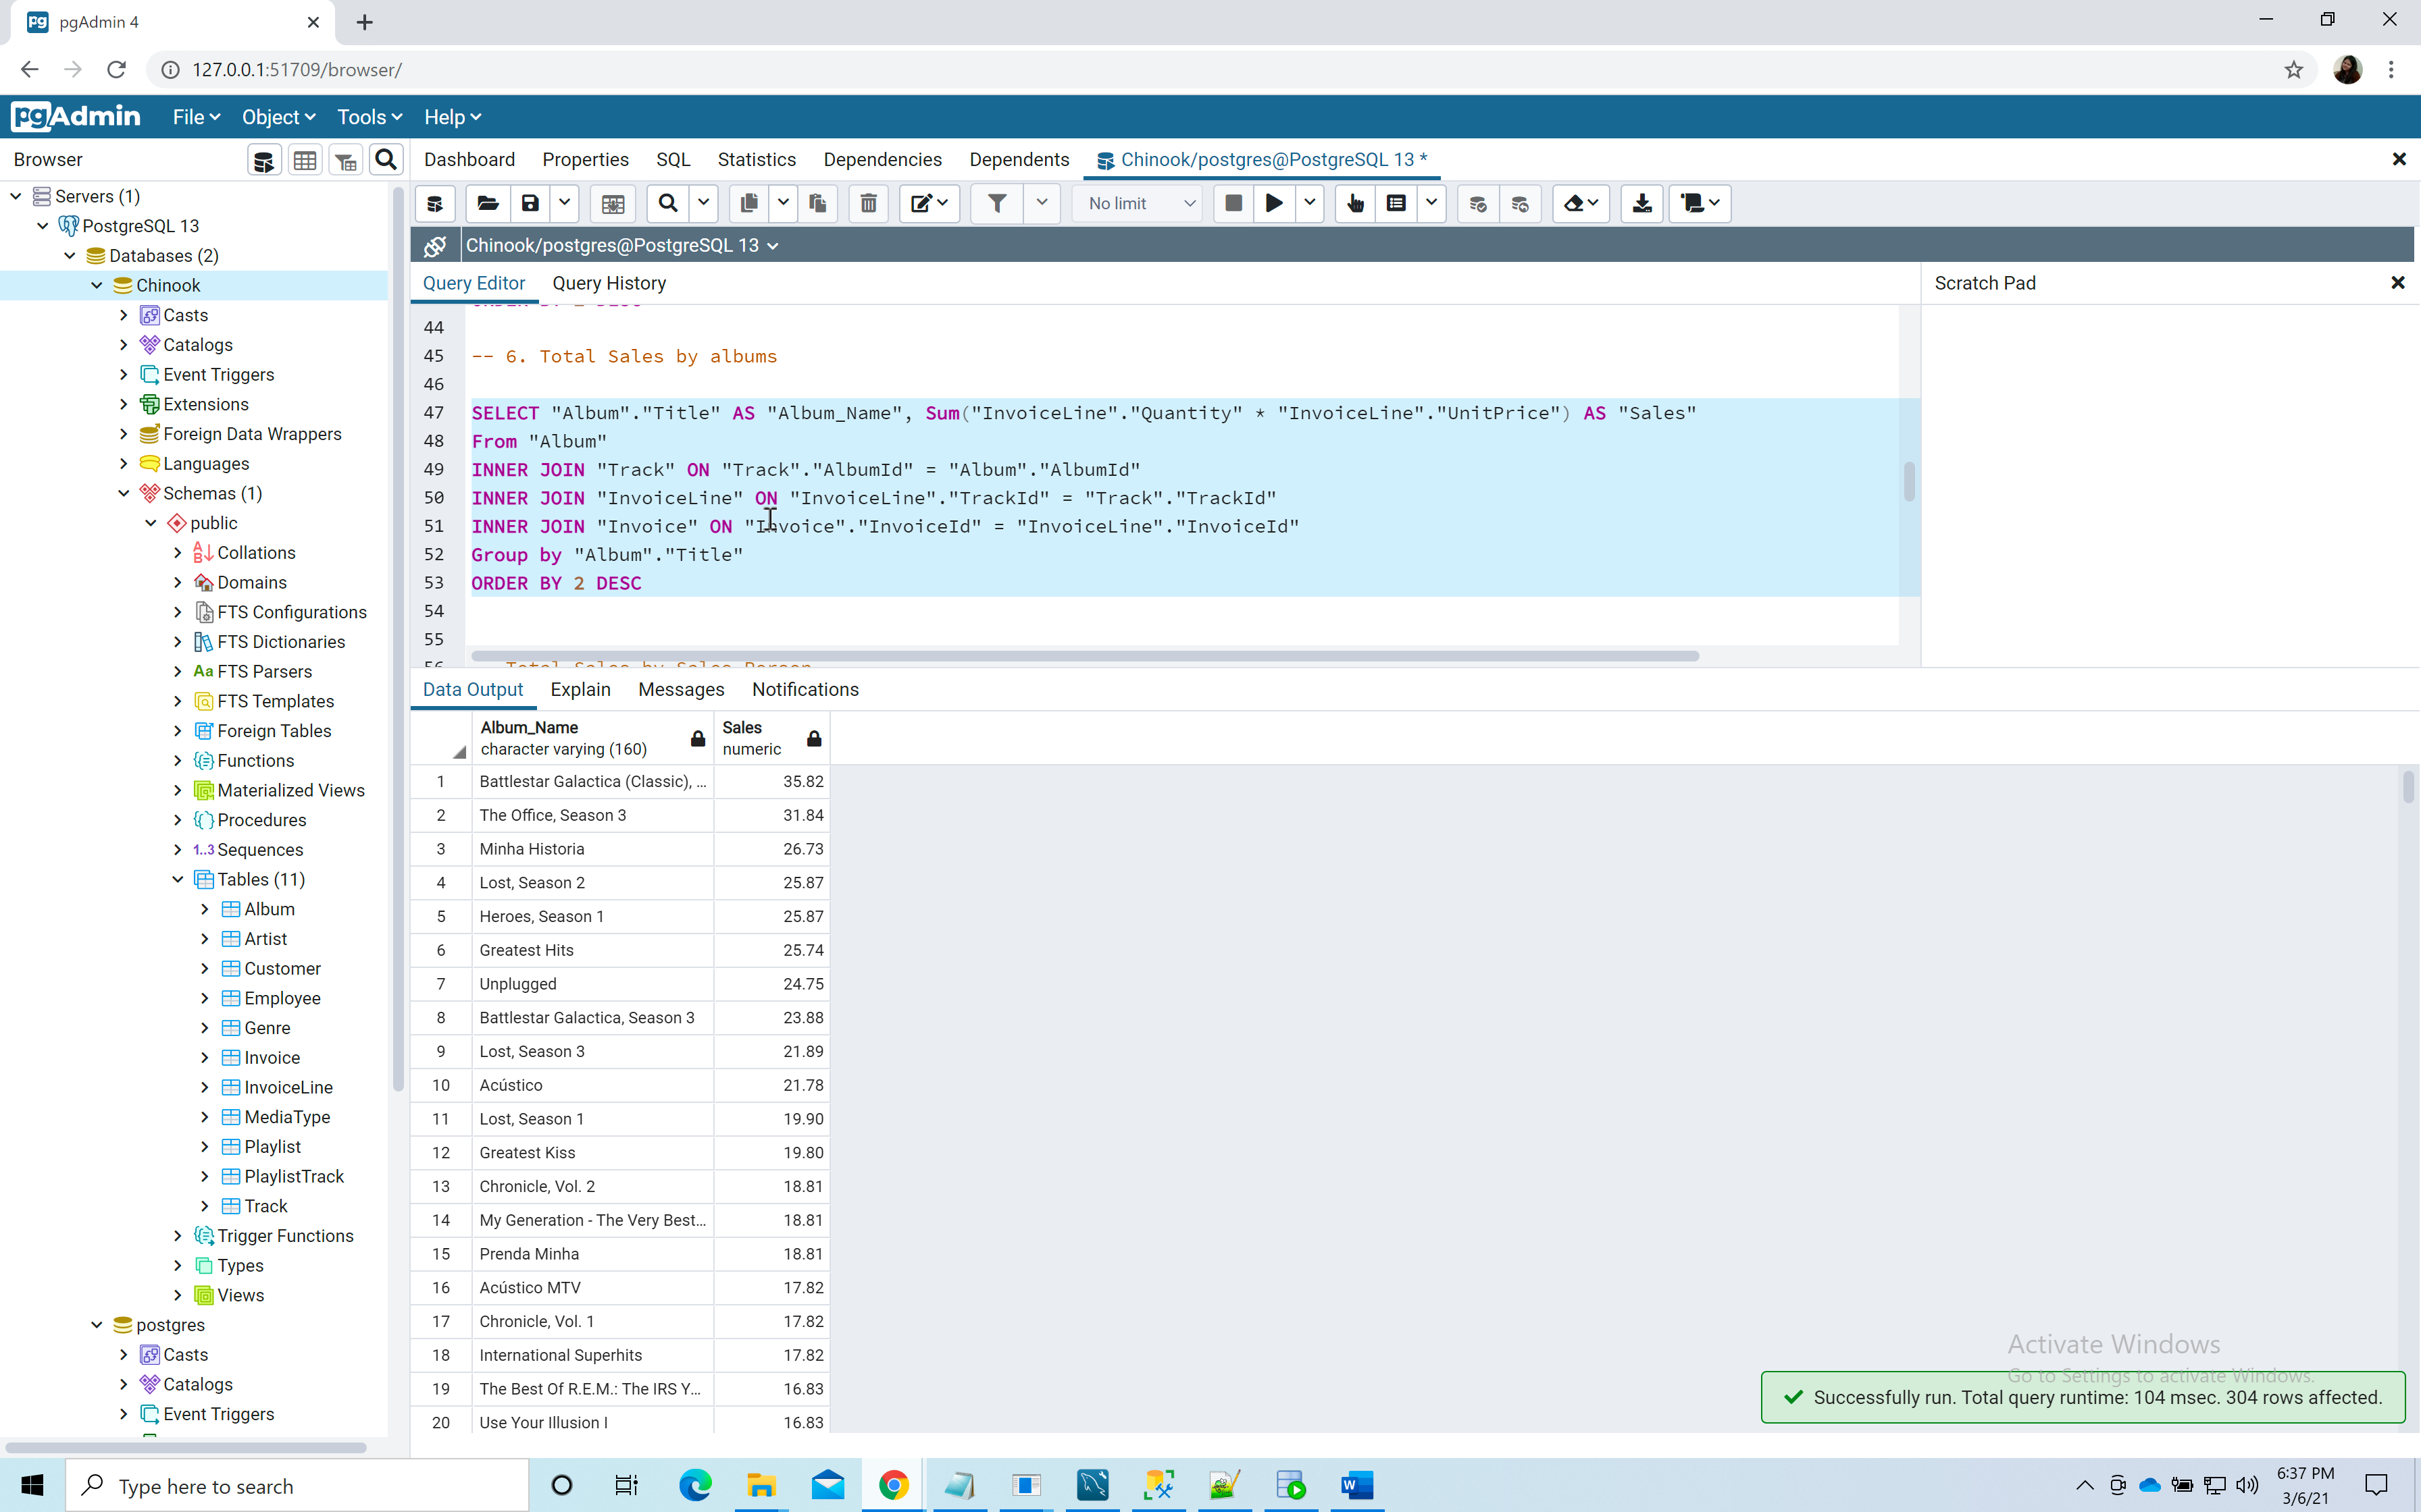

**7.Total sales $ by salesperson (employee)  
Query:**

SELECT

CONCAT("Employee"."LastName",' , ',"Employee"."FirstName")AS "EmployeeName",

Sum("InvoiceLine"."Quantity" * "InvoiceLine"."UnitPrice") AS "Sales"

FROM "Employee"

INNER JOIN "Customer" ON "Employee"."EmployeeId" = "Customer"."SupportRepId"

INNER JOIN "Invoice" ON "Invoice"."CustomerId" = "Customer"."CustomerId"

INNER JOIN "InvoiceLine" ON "InvoiceLine"."InvoiceId" = "Invoice"."InvoiceId"

GROUP BY "Employee"."LastName", "Employee"."FirstName"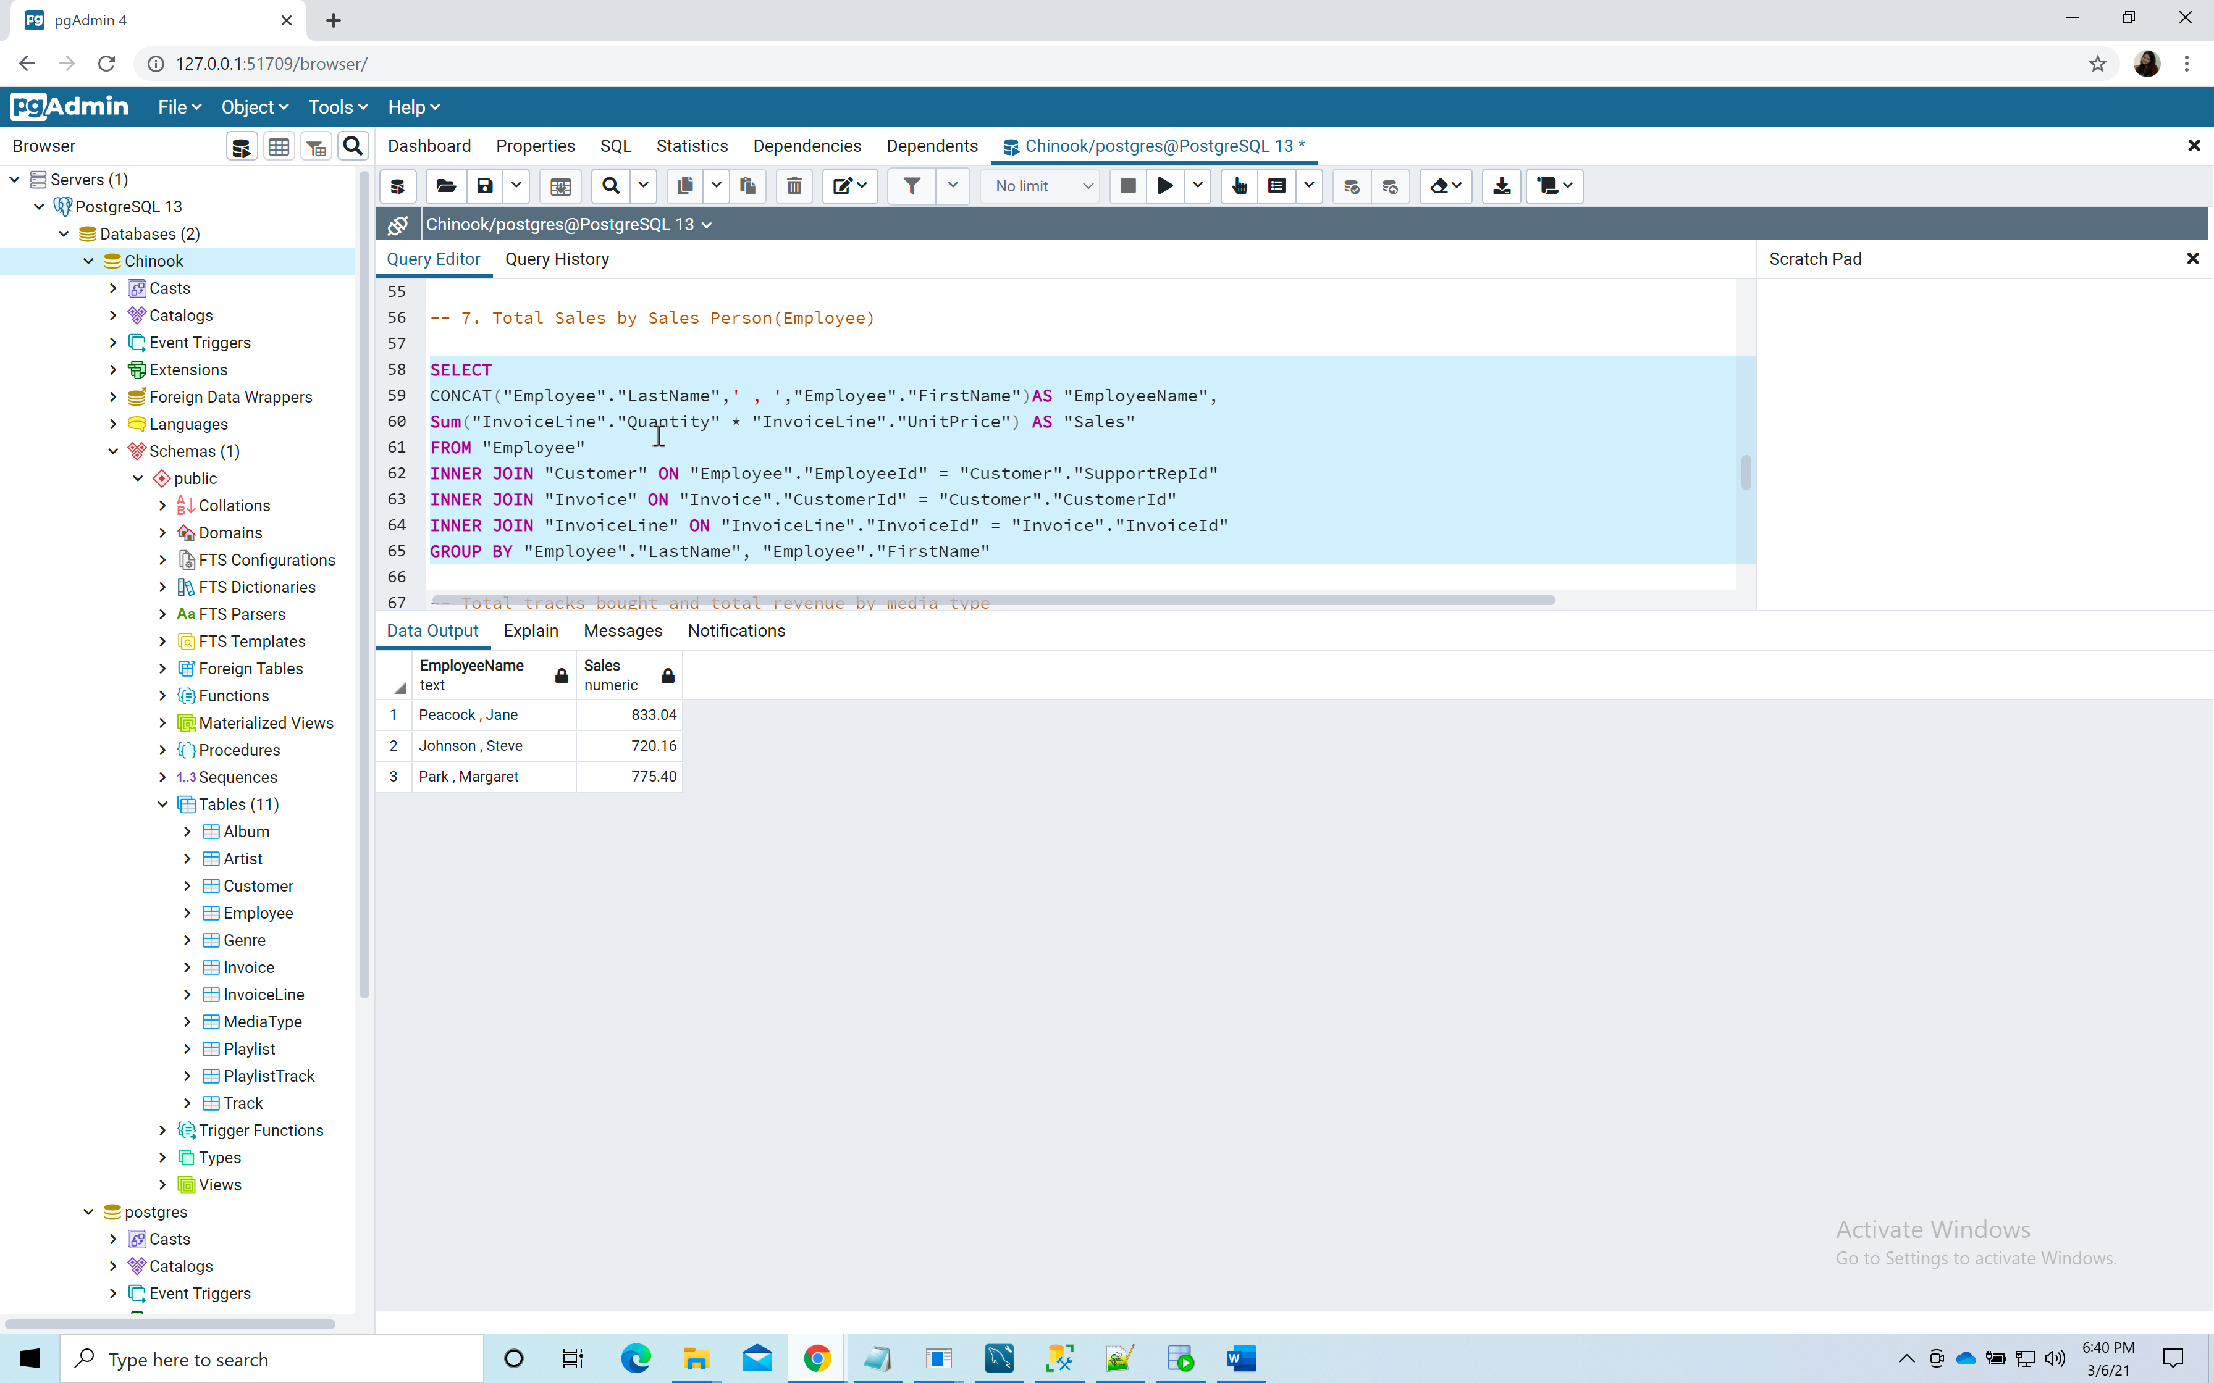

**8.Total tracks bought and total revenue $ by media type  
Query:**SELECT "MediaType"."Name", COUNT("InvoiceLine"."TrackId") AS "Tracks Bought", Sum("InvoiceLine"."Quantity" * "InvoiceLine"."UnitPrice") AS "Sales"

From "Track"

INNER JOIN "MediaType" ON "MediaType"."MediaTypeId" = "Track"."MediaTypeId"

INNER JOIN "InvoiceLine" ON "Track"."TrackId" = "InvoiceLine"."TrackId"

INNER JOIN "Invoice" ON "Invoice"."InvoiceId" = "InvoiceLine"."InvoiceId"

GROUP BY "MediaType"."Name"

ORDER BY 2 DESC;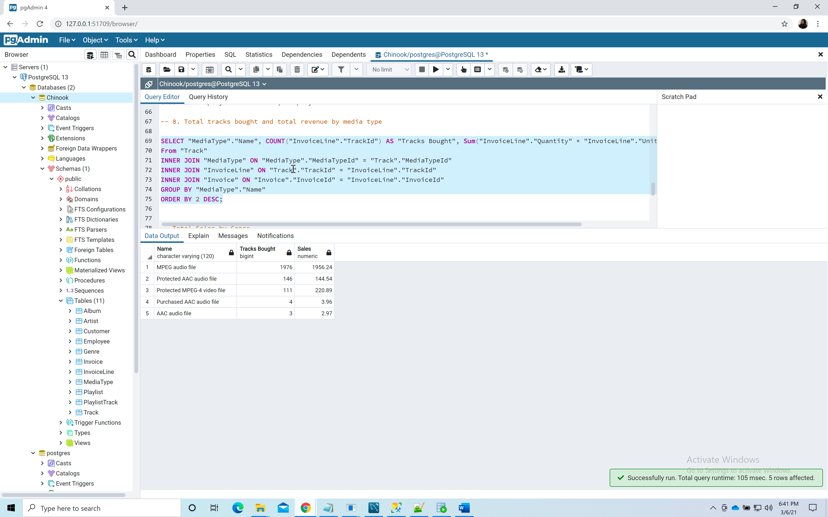

**9.Total sales $ by genre  
Query:**

SELECT "Genre"."Name"AS "GenreName", Sum("InvoiceLine"."Quantity" * "InvoiceLine"."UnitPrice") AS Sales

From "Genre"

INNER JOIN "Track" ON "Track"."GenreId" = "Genre"."GenreId"

INNER JOIN "InvoiceLine" ON "InvoiceLine"."TrackId" = "Track"."TrackId"

INNER JOIN "Invoice" ON "Invoice"."InvoiceId" = "InvoiceLine"."InvoiceId"

Group by "Genre"."Name"

ORDER BY 2 DESC; 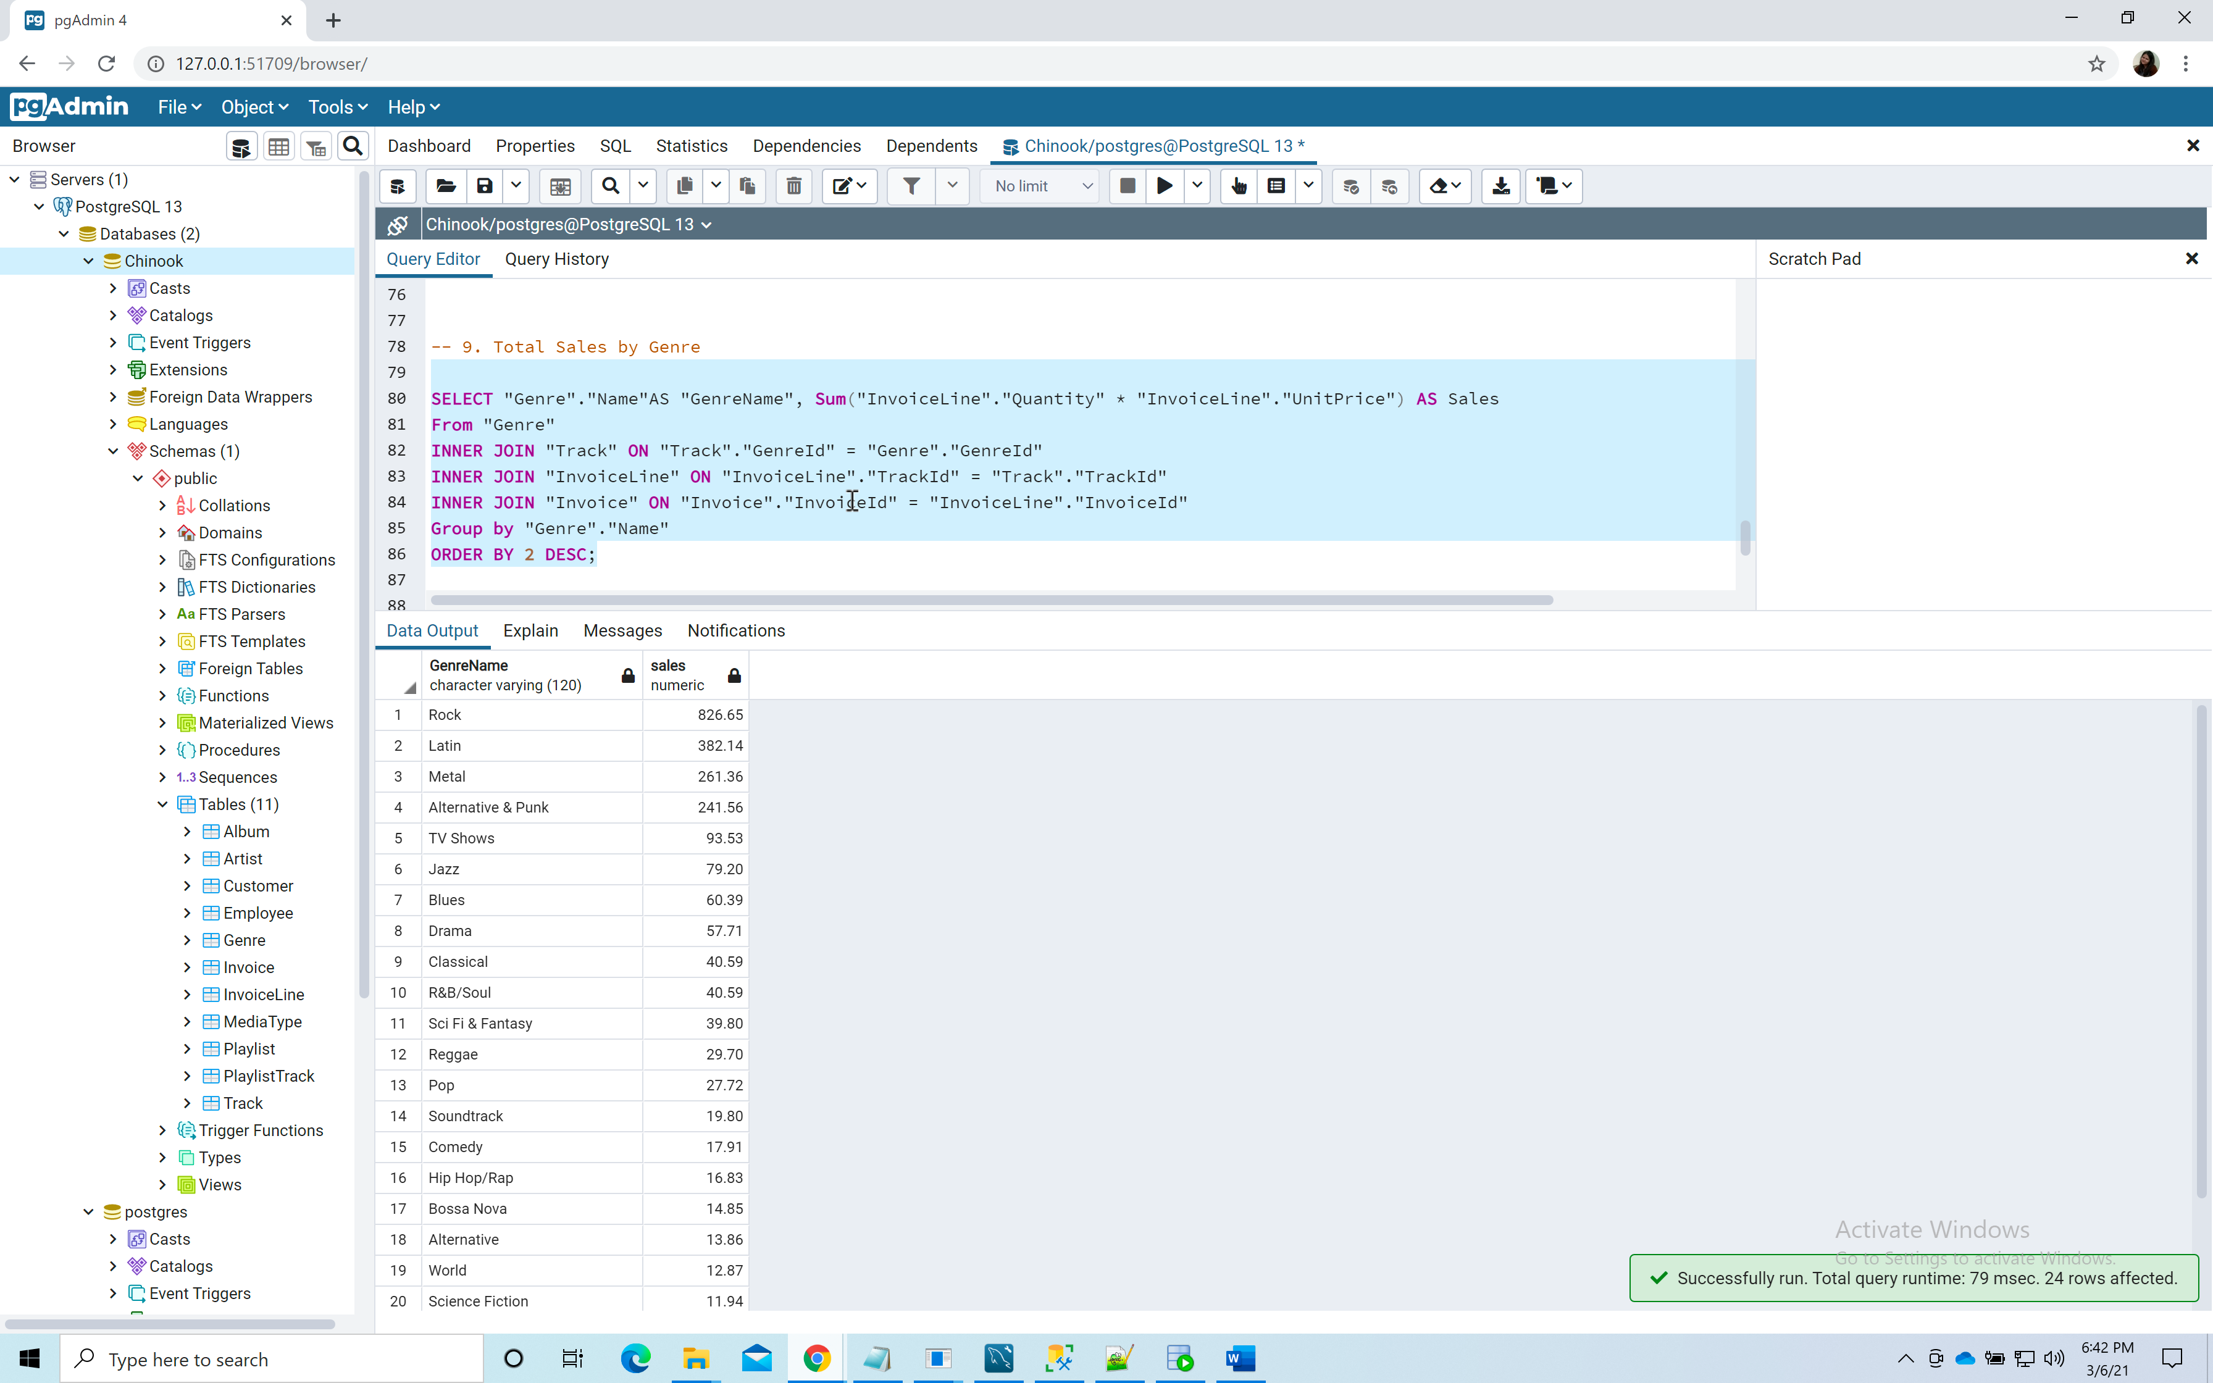

**10.Total sales $ by company**

**Query:**

SELECT CONCAT("LastName",' , ',"FirstName")AS "CustomerName",

"Customer"."Company",

Sum("InvoiceLine"."Quantity" * "InvoiceLine"."UnitPrice") AS "Sales"

FROM "Customer"

INNER JOIN "Invoice" on "Invoice"."CustomerId" = "Customer"."CustomerId"

INNER JOIN "InvoiceLine" ON "InvoiceLine"."InvoiceId" = "Invoice"."InvoiceId"

WHERE "Customer"."Company" IS NOT NULL

GROUP BY "Customer"."LastName", "Customer"."FirstName", "Customer"."Company"

ORDER BY 3 DESC; 